🌱 What are we building?
A simple Spring application where:
- One class depends on another
- Spring injects the dependency using a constructor
Example idea (real-world):
A Car needs an Engine
Car cannot run without Engine → dependency
Spring will inject Engine into Car using constructor

🔹 What is Constructor Injection? (In simple words)
👉 Constructor Injection means:
- Dependency is passed through the constructor
- Object is fully ready at creation time
- Most recommended and safe approach in Spring

🛠️ Step 1: Open STS and Create Spring Project
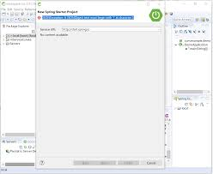
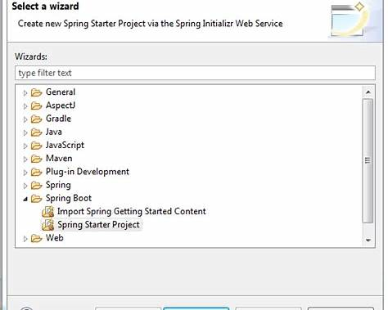
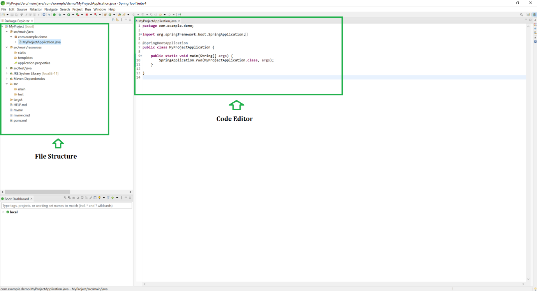
- Open Spring Tool Suite (STS)
- Click
File → New → Spring Starter Project
- Fill details:
  - Name: ConstructorInjectionDemo
  - Type: Maven
  - Java Version: 17 (or default)
- Click Next
- Select:
  - ✅ Spring Web (for simplicity)
- Click Finish
⏳ Project will be created automatically.

📁 Step 2: Understand Project Structure
You will see:
ConstructorInjectionDemo
└── src/main/java
└── com.example.demo
└── ConstructorInjectionDemoApplication.java
This file has main() method.

🔧 Step 3: Create the Dependency Class (Engine)
📍 Path:
src/main/java → com.example.demo
👉 Right click → New → Class → Name: Engine
package com.example.demo;

import org.springframework.stereotype.Component;

@Component
public class Engine {

public String start() {
return "Engine started successfully 🚗";
}
}
🔍 Explanation
- @Component → tells Spring “Create object of this class”
- start() → simple method to show engine working

🚗 Step 4: Create Main Class (Car) with Constructor Injection
👉 Create another class
Name: Car
package com.example.demo;

import org.springframework.stereotype.Component;

@Component
public class Car {

private Engine engine;

// Constructor Injection
public Car(Engine engine) {
this.engine = engine;
}

public void drive() {
System.out.println(engine.start());
System.out.println("Car is running...");
}
}
🔍 Key Points (Very Important)
- Engine is dependency
- Constructor accepts Engine
- Spring automatically injects Engine
- No new Engine() → Spring controls object creation
✅ This is Constructor Injection

▶️ Step 5: Modify Main Class to Test Injection
Open
ConstructorInjectionDemoApplication.java
package com.example.demo;

import org.springframework.boot.SpringApplication;
import org.springframework.boot.autoconfigure.SpringBootApplication;
import org.springframework.context.ApplicationContext;

@SpringBootApplication
public class ConstructorInjectionDemoApplication {

public static void main(String[] args) {

ApplicationContext context =
SpringApplication.run(ConstructorInjectionDemoApplication.class, args);

Car car = context.getBean(Car.class);
car.drive();
}
}

▶️ Step 6: Run the Application
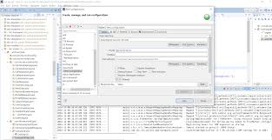
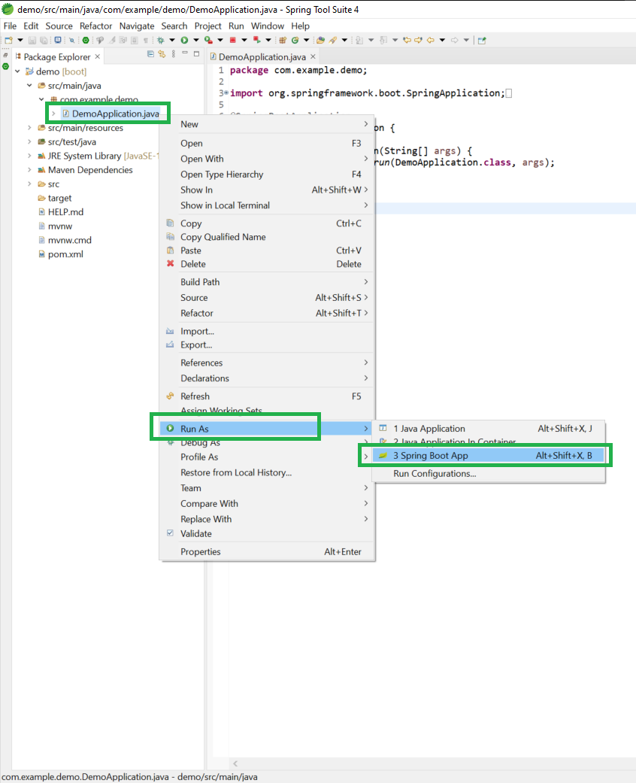
- Right-click project
- Run As → Spring Boot App
- Check Console Output

✅ Expected Output
Engine started successfully 🚗
Car is running...
🎉 Constructor Injection is working successfully!

🧠 What Spring Did Internally (Simple Flow)
- Spring starts application
- Finds @Component classes
- Creates Engine object
- Sees Car needs Engine
- Calls constructor:
new Car(engine)
- Dependency injected ✔️

⭐ Why Constructor Injection is Best?
Reason | Explanation
Safer | Dependency must be provided
Immutable | No setter needed
Testable | Easy for unit testing
Recommended | Preferred by Spring team

❌ What NOT to Do (Bad Practice)
public Car() {
engine = new Engine(); // ❌ Spring not managing
}
❌ Breaks Spring dependency injection
❌ Hard to test
❌ Tight coupling

📝 Summary (For Freshers)
- Constructor Injection = Dependency passed via constructor
- Use @Component
- No new keyword
- Spring creates and injects objects
- Best and safest injection method

